PLUGGING INTO THE FUTURE : AN EXPLORATION OF ELECTRICITY CONSUMPTION PATTERNS

- INTRODUCTION
1.1OVERVIEW:
ABOUT PROJECT :

- The total consumption of electric energy can be divided into several categories, such as lightning,heating,communication,information,and others.Concerning the worldwide situation, it is estimated in Ref.[5] that electric motor driven systems (EMDSs) account for between 43% and 46% of the global electricity consumption.This amount is more than twice that of the second largest,which is lightning,contributing by 19% to the total consumption.
- The share of electric energy consumption by motor-driven systems to the various sectors of application is given in Ref.[5]as: with total consumption of about 7100TWh/year.
- This value is expected in 13,000TWh/year by 2030 if no comprehensive and effective measures to improve the energy efficiency of motor-driven systems are taken soon.
- The global consumption of electric energy by electric motors is dominated by four major motor applications.According to Refs[5,8][5][8],in 2006 the corresponding share was as follows:compressor 32%,mechanical movement 30%,pumps 19%,and fans 19%.
1.2 PURPOSE OF THE PROJECT:
- The primary purpose of reducing energy use in your home saves you money,increases our energy security,and reduces the pollution that is emitted from non-renewable sources of energy.
- Heating and cooling our homes,lightning office buildings,driving cars ad moving freight,and manufacturing the products we rely on in our daily lives are all functions that require energy.

- PROBLEM DEFINITION AND DESIGN THINKING:
2.1 EMPATHY MAP:
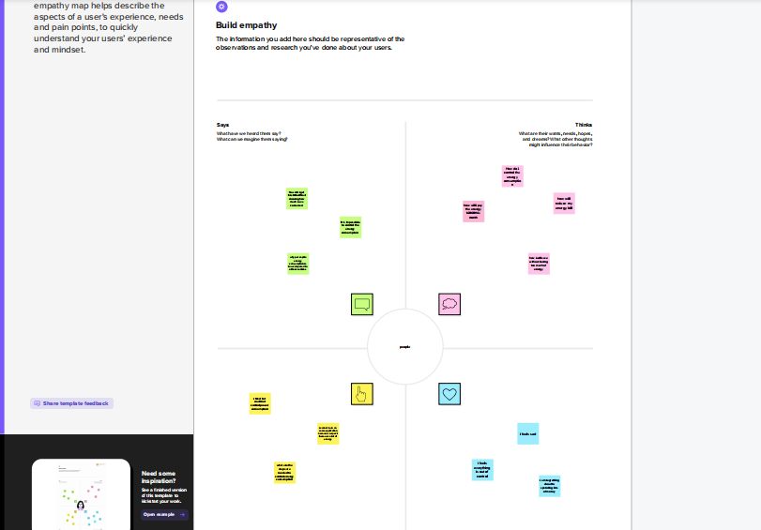

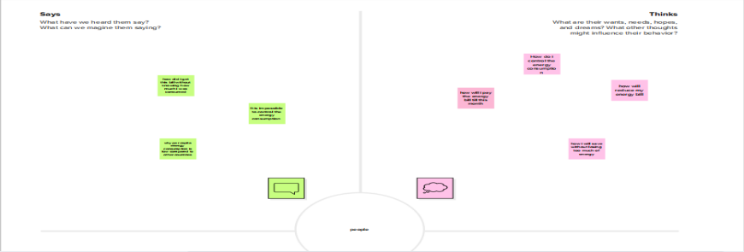

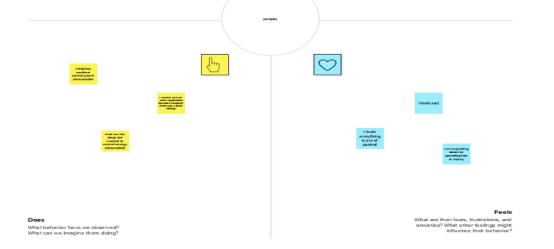

2.2IDEATION AND BRAINSTORMING MAP:

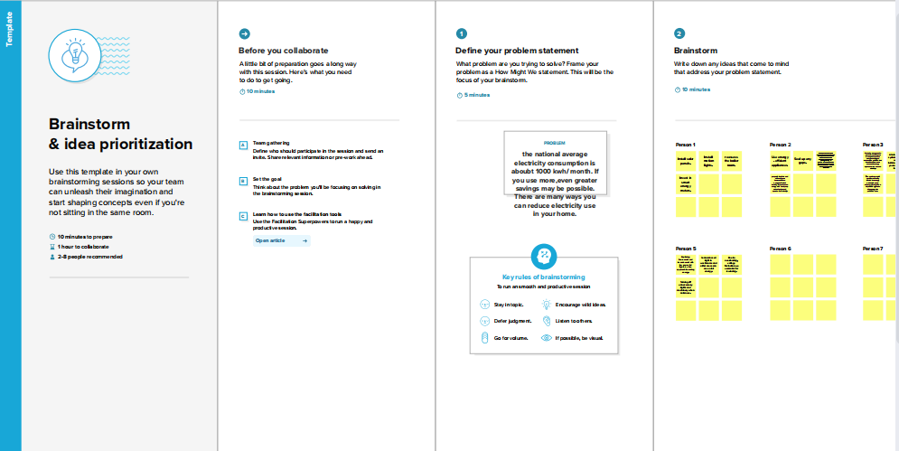

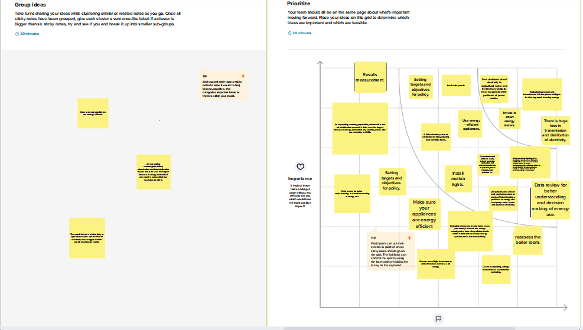
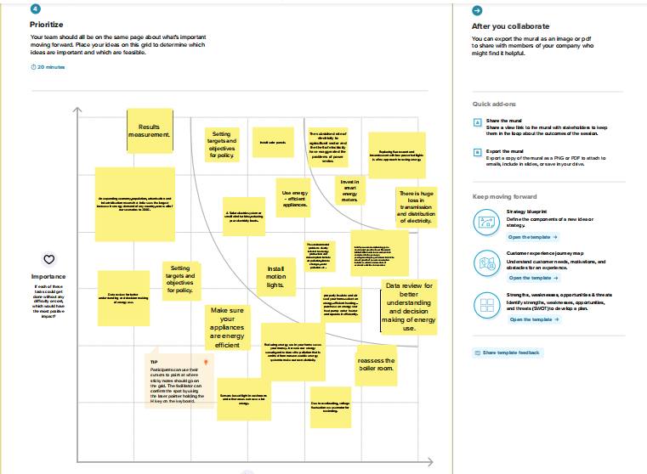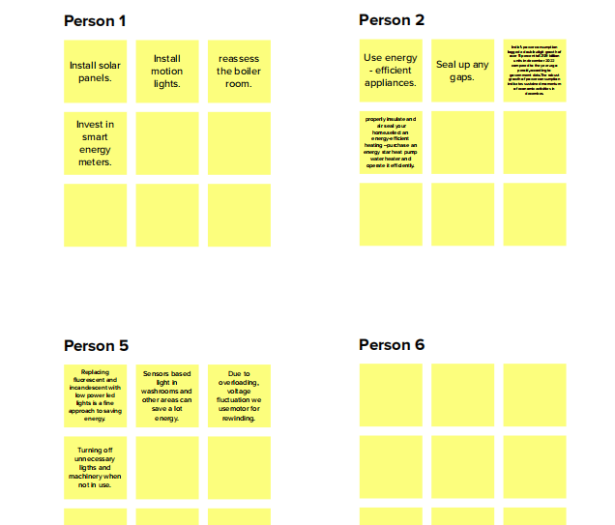

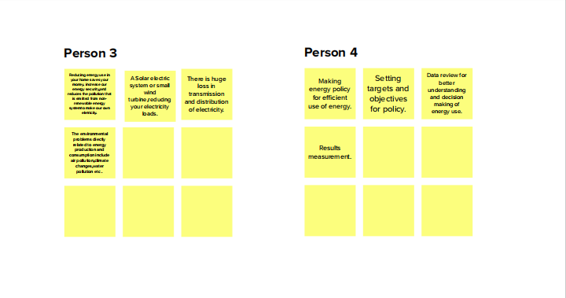

The above map represents the details about what is the problem is,and what are the ideas of each team member and what are the group ideas and which should be prioritize first.
It shows our clear idea about our project.

- RESULTS:
Here we share the final findings of the project like dashboard,Story and the web page we create.
- DASHBOARD

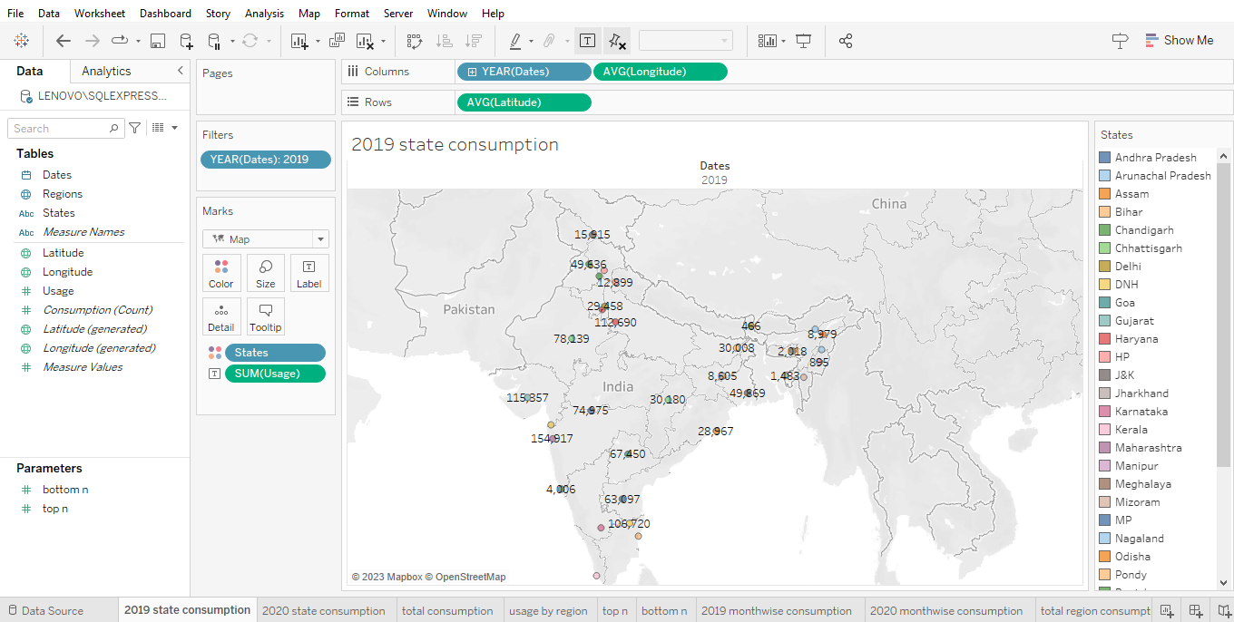

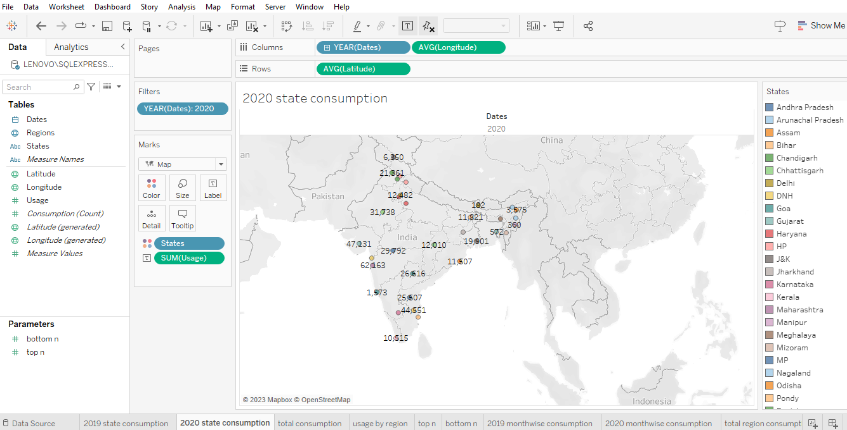

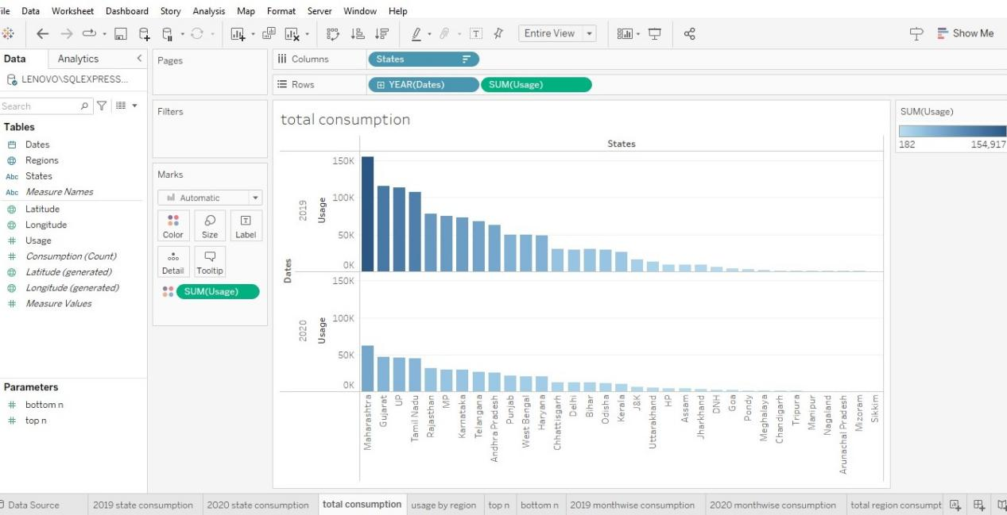

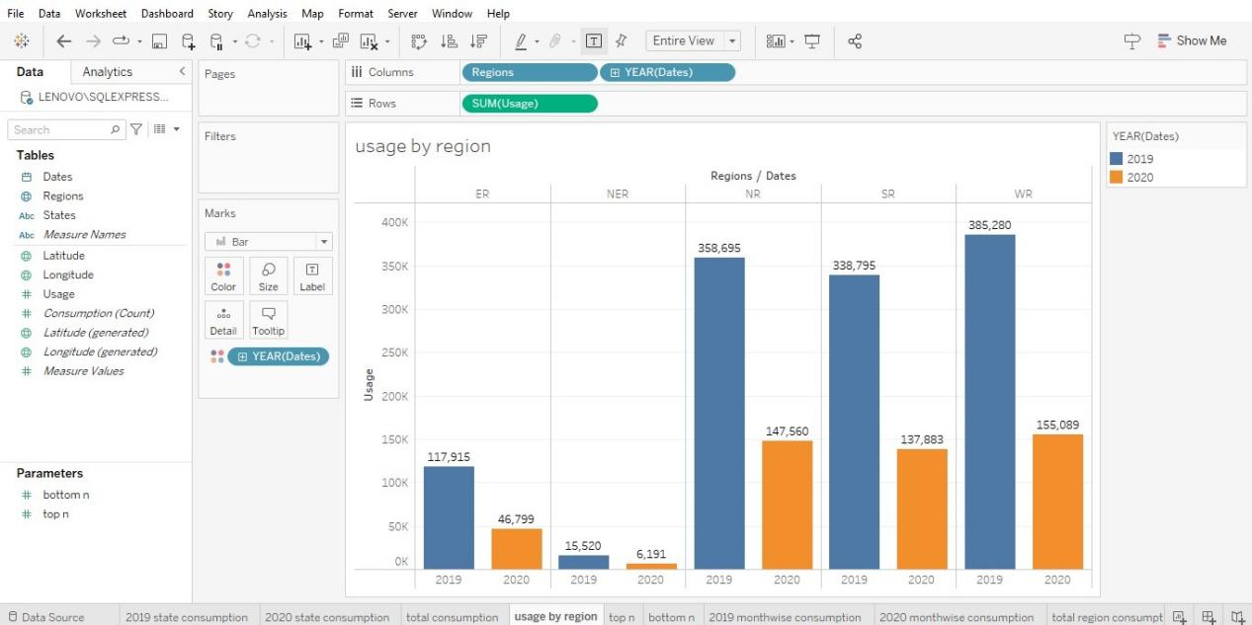
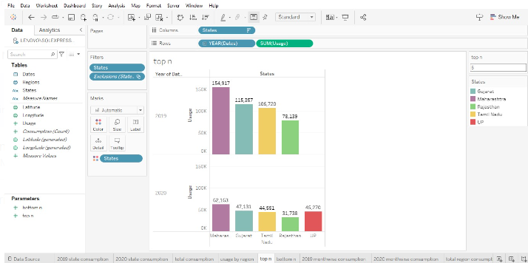

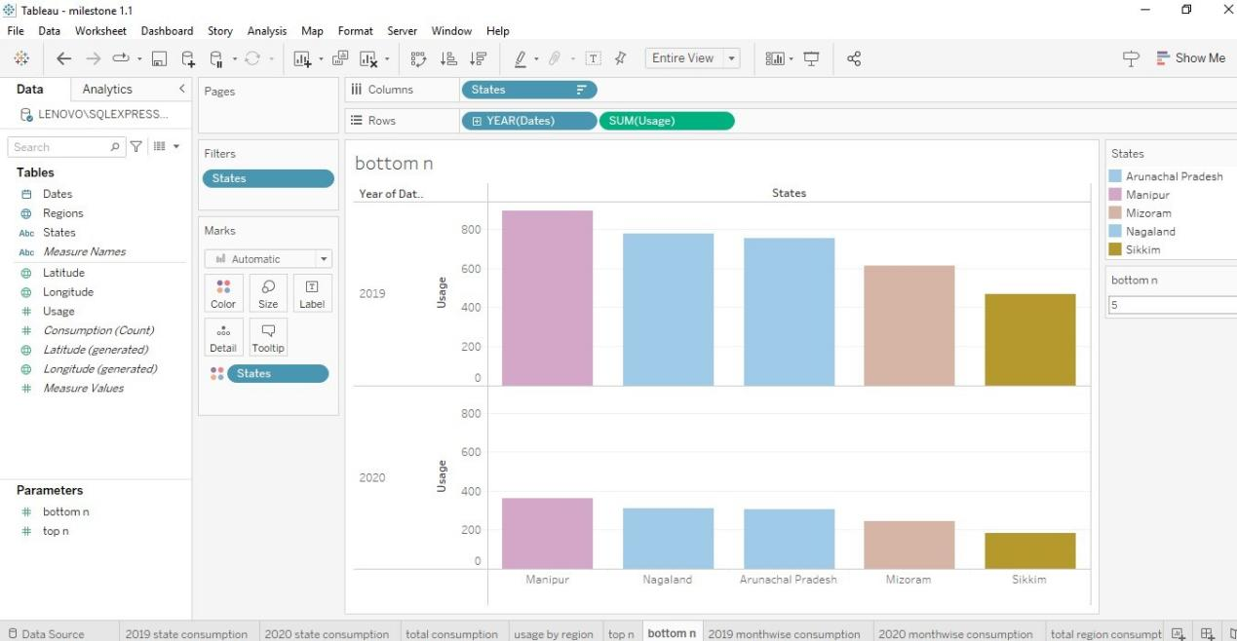

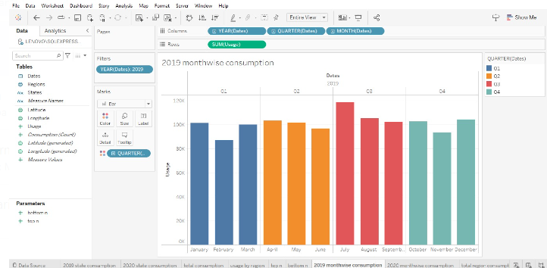

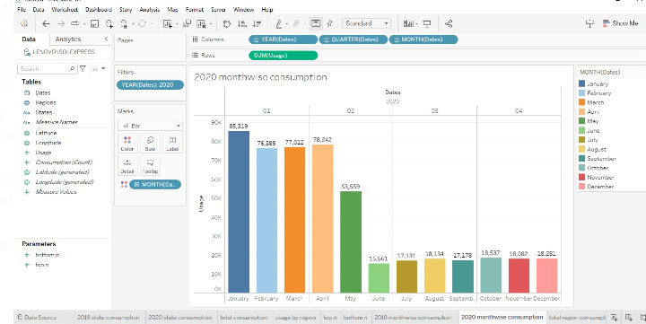

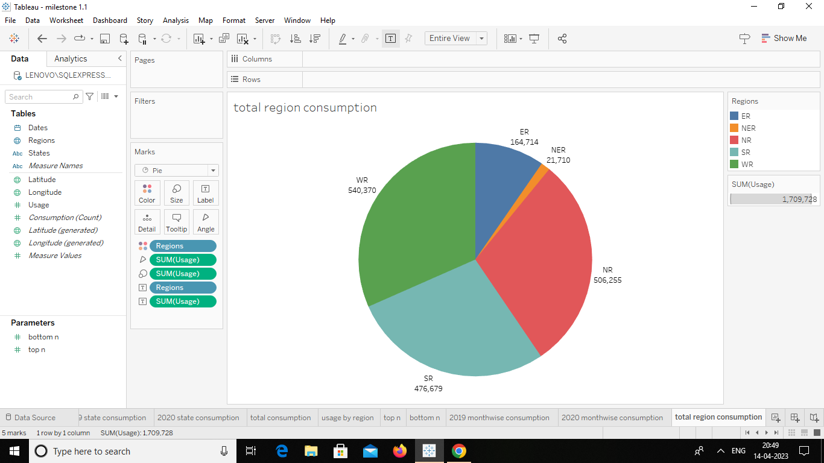

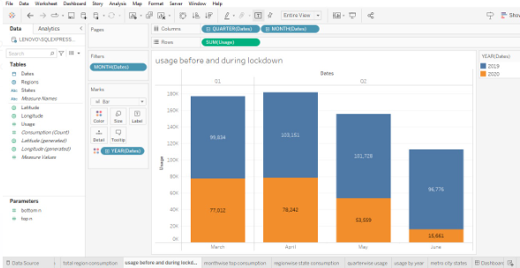

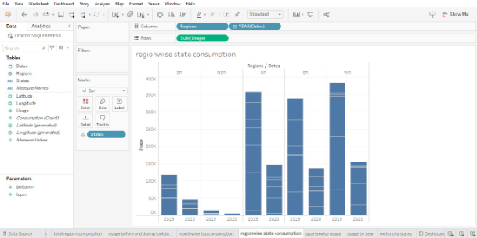

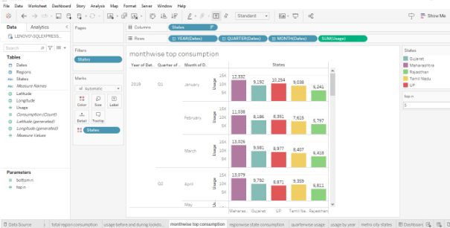

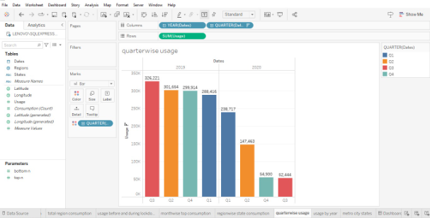

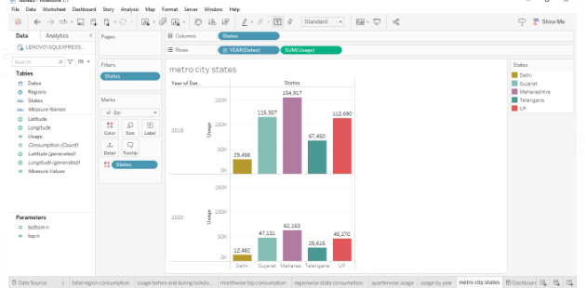

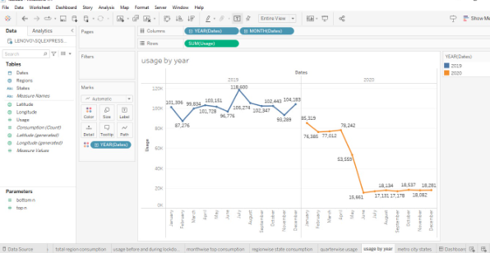

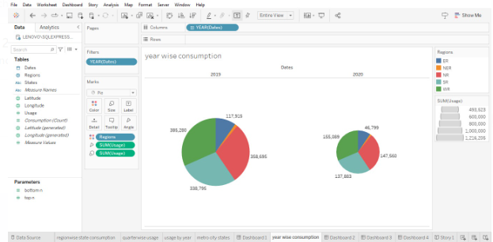

- STORY:

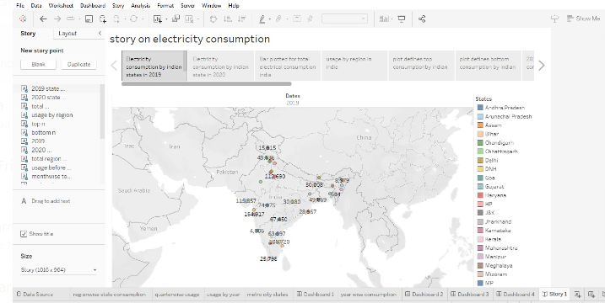

WEB INTEGRATION OUTPUT:

In this field we show you the web integration we made through the HTML file and this is the final output of our project.

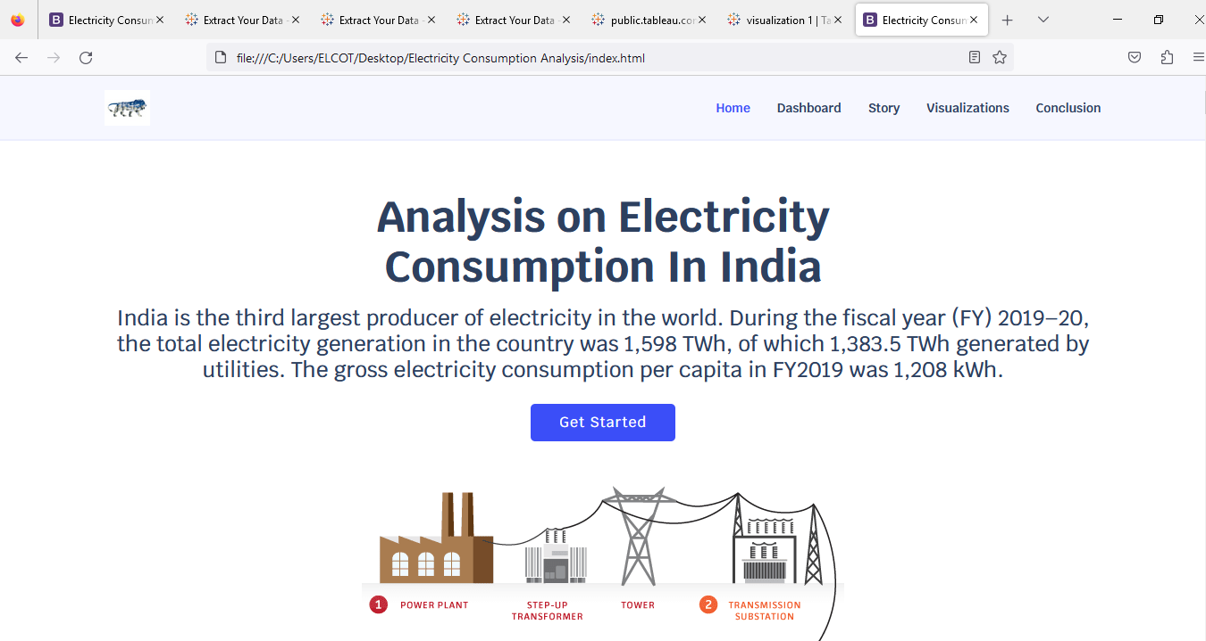

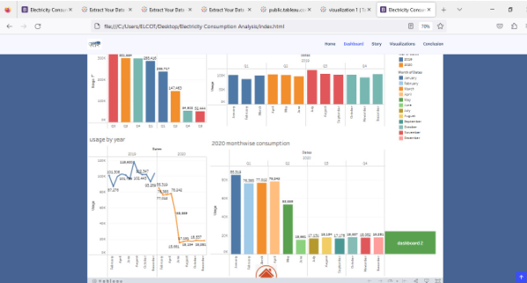

VISUALIZATION

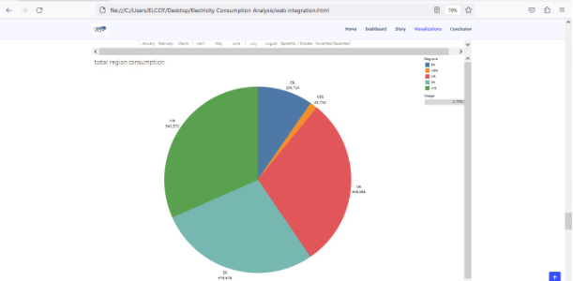

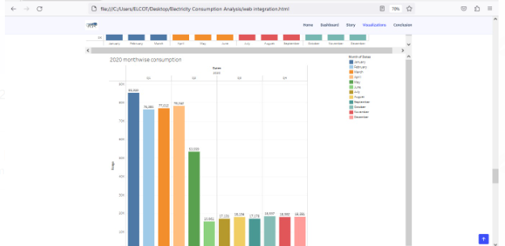

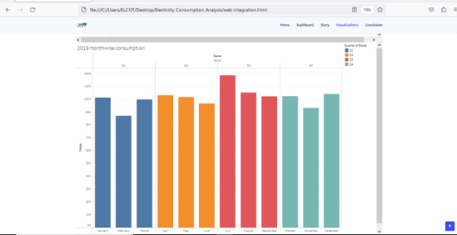

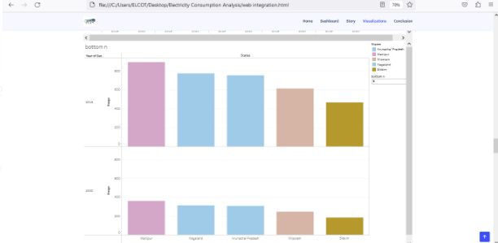

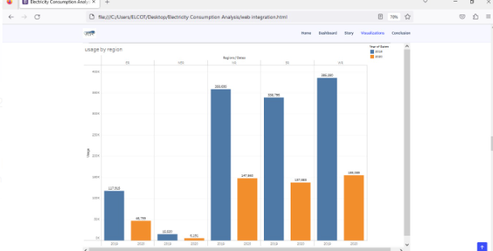

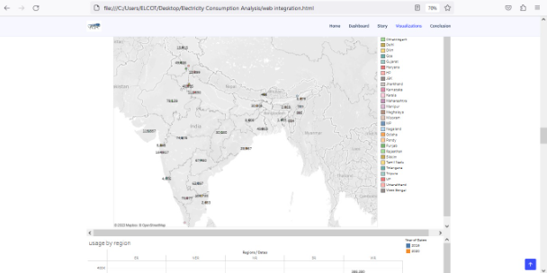
4.ADVANTAGES

- These types of energy sources are environmentally friendly.They do not release toxic gases like carbon dioxide.
- These energy sources do not run out and replenish naturally.
- They are safer for our health as they don’t generate toxic residues harmful to people.
- They also freely exist in nature.

DISADVANTAGES

- Maintenance costs of windmills are very high.
- Renewable sources of energy are not abundant at every place on earth.
- In the case of windmills, the amount of electricity obtained from one windmill is very less hence this makes the entire setup costs of windmills very high.
- Solar energy is not sufficiently stored when there is a cloudy day.only on sunny days, a greater amount of solar energy can be stored.
5.APPLICATIONS:
It is applied in many areas like

- Lighting
- Heating
- Cooling
- Refrigeration
As well as to power appliances, computers,electronics,industrial systems,and public transit systems.
Electric current is used to run many devices such as refrigerators,electric fans and many household items.Electricity is used as electric energy and converted into light energy such as electric bulbs and mechanical energy such as electric motors.
Annual electricity consumption per capita serves as an important measure of a country’s electric power development.Generally speaking,electricity consumption grows faster when the industrialization process develops quickly and goes down rapidly when industrialization is completed or near completion.

Purpose:

A natural consequence of overusing energy is increased costs for you.This can came in the form of fuel and energy bills;you will be paying more without an appreciable return on your investment.you may also risk lowering the expected lifespan of appliances and other electronics.Aswe continue to waste electricity,we continue to emit more carbon and methane into our atmosphere.With fossil fuel gases trapped in our atmosphere,we end up with scorching summers and brutal winters.

6.CONCLUSION
We done our project by using tableau.In our project we build the visualizations,and we drag all the visualizations to our dashboard and same as we drag the visualizations to our stories also.After that we publish the visualizations,Dashboard,Story in Tableau public.Then for the next level we done the web integration by using Bootstrap made.
In our we understood how to analyze the data and how to create the new charts,filters etc.

7.FUTURE SCOPE:
These are the future scopes to build the project next level,
In the Stated Policies Scenario,global electricity demand grows at 2.1% per year to 2040,twice the rate of primary energy demand.This raises electricity’s share in total final energy consumption from 19% in 2018 to 24% in 2040.Electricity demand growth is set to be particularly strong in developing economics.It reducing the amount of primary energy consumed to supply the useful energy requirement (energy efficiency),and reducing the end point use of nonessential energy.

